Dromin National School
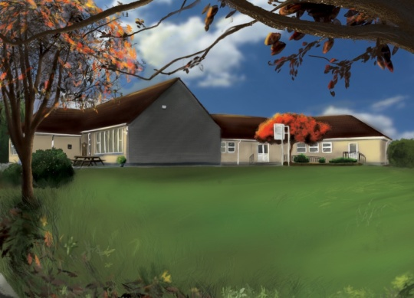
2nd Class Booklist 2022-2023

1. Booklist:
Items in black to be purchased by parents/guardians.
Items in red are part of book rental and will be distributed in September.

Subject | Book | Publisher | Buy | Rent
English | Words Words Words (use same book as last year)  Starlight - Combined Reading & Skills Book  Starlight 2nd Class Skills Book  Write Here Book D  Fallons Table Book  Spell It! 2nd Class  Sounds Make Words 2nd Class  New Wave English in Practice 2nd Class  Starlight Core Reader 2nd Class | Edco  Folens  Folens  Folens  Fallons  Folens  Folens  Prim Ed  Folens | € -  €11.20  € 9.95  € 6.30  € 2.70  € 8.70  € 8.10  € 6.99  € 9.65 | €3.00
Maths | Busy at Maths 2  Busy at Maths Shadow Book 2  New Wave Mental Maths 2nd Class | Fallons  Fallons  Prim Ed | €20.50  € 8.70  € 8.99
Gaeilge | Abair Liom 1 – 2nd Edition  Craic Le Litriú A | Folens  Gill&Macmillan | €14.95  € 9.95
SESE | Let’s Discover! 1st Class | Fallons | €13.85
Religion | Grow in Love 2nd Class | Veritas | €10.50
Homework | Homework Diary  Plastic Folder x 1  Multi-Coloured Pen | Fallons  -  BIC | € 3.50  € 3.00  € -
Prices may vary with different retailers.
2. Stationary: (All copies, pencils & crayons will be purchased by the class teacher in September).
Stationary & books must be clearly labelled.
3. Costs of Fees:
BOOK RENTAL € 3.00
Art & Craft Materials/Photocopying/Ink €35.00
Copies, Pencils, Crayons €15.00
Writer’s Workshop Portfolio € 2.00
I.C.T. Text-A-Parent/Aladdin € 4.00
Insurance: 24-hour cover € 6.00
€65.00
Total Fees Due:

4. Payment: (Child’s Name & Class referenced on all payments).
This amount of €65.00 should be paid by Electronic Transfer (ET) to the following account:
BIC: BOFIIE2D IBAN: IE61 BOFI 9034 2924 9056 72
** When paying by ET, please remember to put your child’s name as payment reference so the monies can be allocated to their profile. Alternatively, monies can be paid by cash or cheque (payable to Dromin N.S.) to the class teacher before Friday the 24th June, 2022**.

